Lancashire County Council
Health Overview and Scrutiny Meeting
Healthier Lancashire and South Cumbria System Update
Integrated Care System update |  | Chief Officer: Dr Amanda Doyle  Executive Director for Commissioning: Andrew Bennett  Executive Director for Finance and Investment: Gary Raphael  Communications and Engagement Lead: Neil Greaves
PERIOD OF REPORT | 5 February 2019
FOR INFORMATION

- Introduction
This report provides a high-level overview of the partnership in Lancashire and South Cumbria which is working as an Integrated Care System (ICS). The name of the partnership of NHS, Local Authority and Public Service organisations is Healthier Lancashire and South Cumbria.

Healthier Lancashire and South Cumbria covers a region made up of five local areas called Integrated Care Partnerships (ICP). These are Central Lancashire, West Lancashire, Pennine Lancashire, Fylde Coast, and Morecambe Bay. These areas provide a way for organisations and groups involved in health and care to join up locally.

Partners include:
- Clinical Commissioning Groups: Greater Preston, Chorley and South Ribble, East Lancashire, West Lancashire, Blackpool, Fylde and Wyre, Morecambe Bay, Blackburn with Darwen
- Five acute and community trusts: Lancashire Teaching Hospitals NHS Foundation Trust, University Hospitals of Morecambe Bay NHS Foundation Trust, East Lancashire Hospitals Trust, Blackpool Teaching Hospitals NHS Foundation Trust and Lancashire Care NHS Foundation Trust
- Two upper tier councils (Lancashire and Cumbria) and two unitary councils (Blackpool and Blackburn with Darwen)

The integrated care system is clinically led by Dr. Amanda Doyle with support from senior clinicians and managers from every part of Lancashire and South Cumbria.

The Lancashire Health Overview and Scrutiny Committee was updated on the progress of partnership working and the development of a shadow integrated care system in April 2018. This report provides an update of progress and the early implications from the recent publication of the NHS Long Term Plan.

2. Executive Leadership
Since the last briefing, a recruitment process has been completed and a team of executive leaders are now in place for the Integrated Care System (shown in Figure 1).

The executives for Healthier Lancashire and South Cumbria are:
- Dr Amanda Doyle, Chief Officer
- Andrew Bennett, Executive Director of Commissioning
- Jane Cass, Director of Assurance Delivery & Performance
- Dr Andy Curran, Executive Medical Director
- Jackie Hanson, Director for Nursing & Care Professionals
- Gary Raphael, Executive Director of Finance & Investment
- Talib Yaseen, Executive Director for Transformation
- Carl Ashworth, Director of Strategy and Policy
- Elaine Collier, Director of Finance for NHS England

Figure 1: ICS Executive Structure
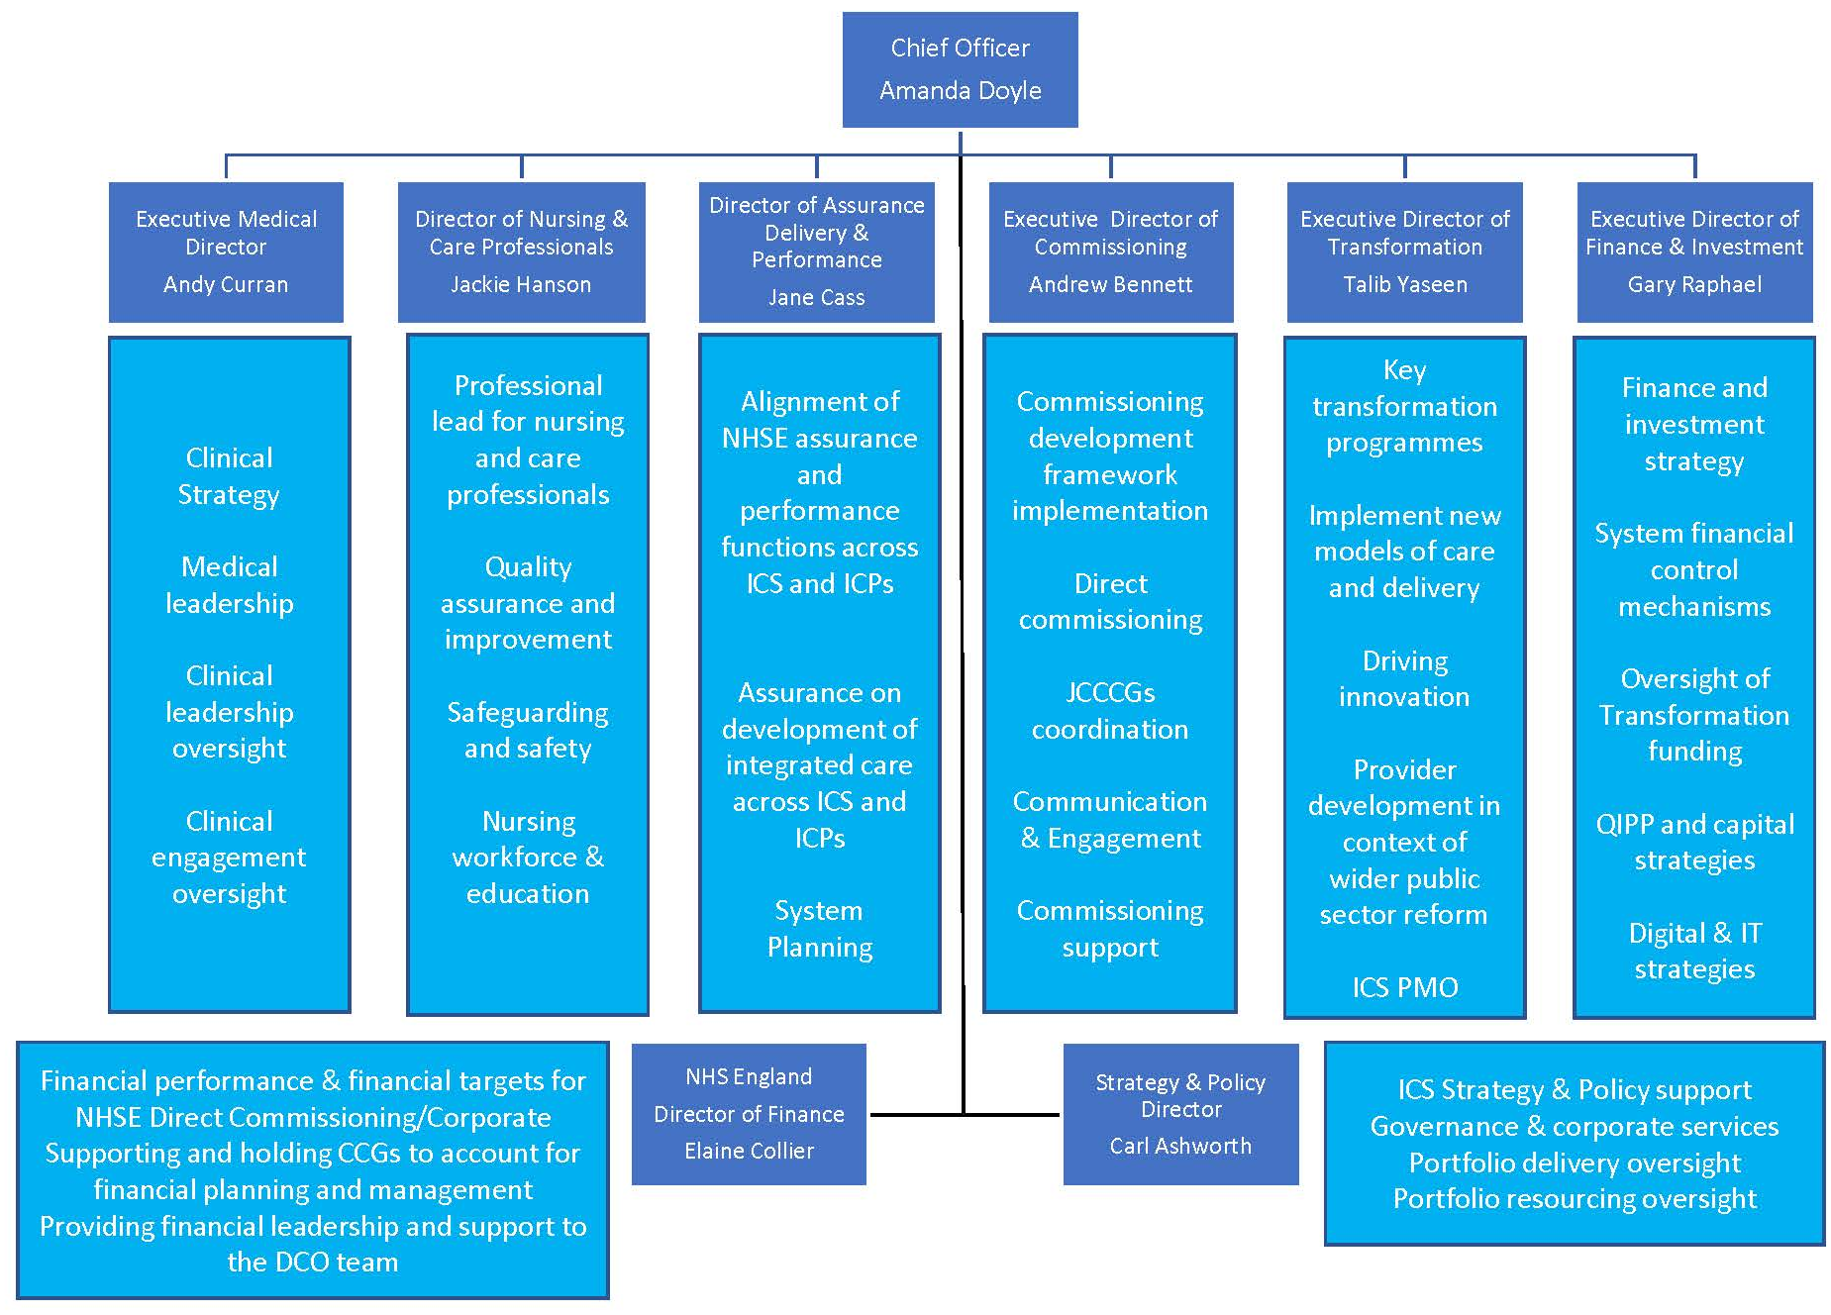

The executive team has been fully in place since September 2018 and has been working to review and reshape the collaborative work of all partners within Lancashire and South Cumbria.

One of the early priorities has been to review progress on the major workstreams which the partners agreed to pursue in our “sustainability and transformation plan” in 2016 and were presented to the committee in April 2018 (see Figure 2). Each workstream now has an ICS Executive sponsor working with commissioning, provider and project manager colleagues to take this work forward.

Figure 2: Healthier Lancashire and South Cumbria Portfolios
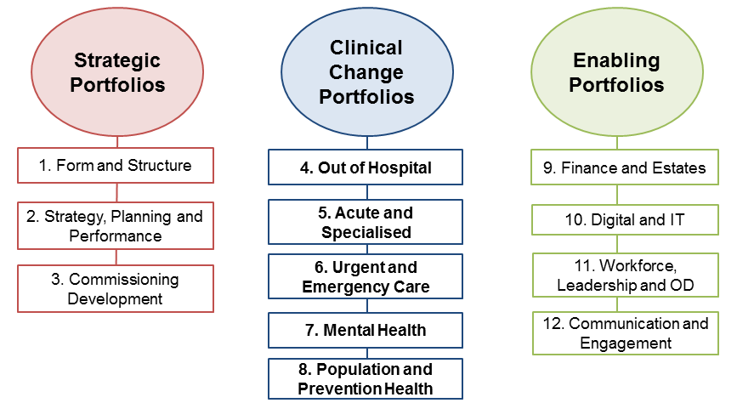

The executive leadership team has been working closely with senior leaders and identified Portfolio/Workstream Leads to confirm the purpose and objectives of each workstream and the resources which are required to take this work forwards.

The diagram in Figure 3 shows the governance structure in place for Healthier Lancashire and South Cumbria.

Figure 3: Healthier Lancashire and South Cumbria governance
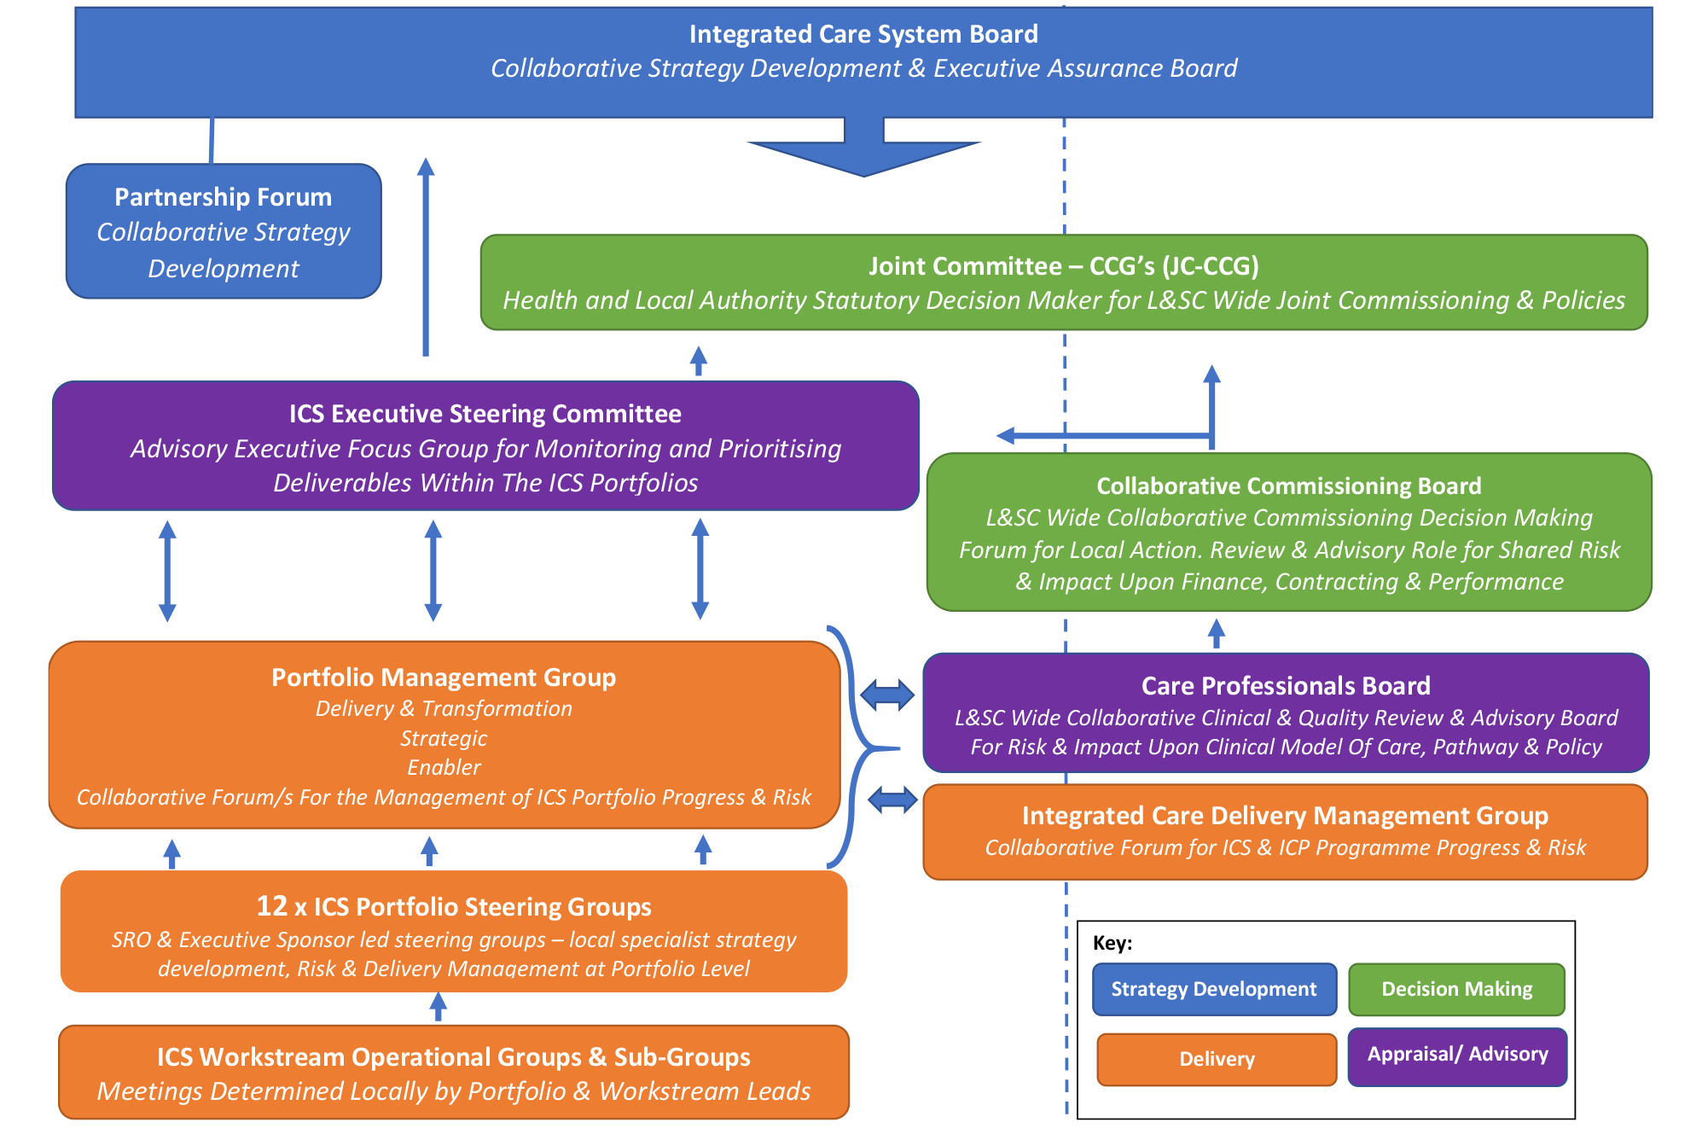

Additional resource to support the major priorities and workstreams of the ICS has been invested in a Programme Management Office (PMO) from October 2018 and this is now overseen by the Head of PMO. During October and November a Portfolio Management Governance Framework was developed to add structure to the twelve ICS Portfolios of work, and the forty-two programmes within them. This has created a standardised framework for the Portfolios to support engagement, progress against plans, decision making and monitoring robustly supporting the breadth and diversity of the type of programmes.

Examples of significant progress in partnership working during 2018:

Mental Health:
A significant increase in the demand for urgent mental health services across Lancashire and South Cumbria led to a Risk Summit for health leaders on 18 April 2018. This resulted in the development of a single Mental Health Improvement Plan for Lancashire and South Cumbria developed jointly by commissioners and Lancashire Care NHS Foundation Trust. This has seen additional resources invested by partners to reduce demand on mental health services.

NHS, Local Authority, Third Sector, Police and other emergency services across Lancashire and South Cumbria are working together to review urgent and emergency mental health services with support from Northumberland, Tyne and Wear NHS Foundation Trust who have been independently leading the review. The review is looking at mental health challenges across the region to identify ways to improve the quality of services provided to people with mental health conditions.

Digital Health:
Healthier Lancashire and South Cumbria launched its digital health strategy ‘Our Digital Future’ in June 2018: https://healthierlsc.co.uk/digitalfuture This strategy sets out how digital tools, services and new ways of working will support the future improvement and transformation of health and care services across the region. It outlines a set of shared principles aligned to five inter-connected strategic themes: empower the person, support the frontline, manage the system more effectively, integrate services and create the future. At the heart of this is our goal to empower local people to live longer, healthier lives.

A core feature of the digital strategy centres around engaging people, patients, voluntary, community and faith organisations - as well as health and care services themselves - in making decisions about how we can use digital to improve the health and care of local people. To begin this process, we asked the Healthwatch Collaborative (Blackburn, Blackpool, Cumbria and Lancashire) to help us hear from local people and to:
- explore how they currently use technology to manage their health and wellbeing and that of their families
- learn about the challenges people might face when using digital technology
- understand how we can better support people to use digital tools and
- hear ideas about improvements we could make in the future.

The engagement programme was undertaken during the summer and autumn months of 2018 and included the collection of 1,225 survey responses (online and paper survey), in depth conversations with people at 38 community engagements and a further 12 focus groups involving 185 people. The resulting report was published by Healthwatch at the end of January 2019, and we will use the recommendations made by local people to inform the digital delivery plan for 2019/20 as we bring the digital strategy to life.

Stroke: Partnership approach is being taken to the whole Stroke Programme in Lancashire and South Cumbria, focussing on the different phases of the end to end stroke pathway including stroke prevention, hospital-based treatment, integrated community stroke rehabilitation and life after stroke. The progress is described in the supporting paper.

3. The NHS Long Term Plan
On Monday 7th January 2019, NHS England published the 133-page NHS Long Term Plan which outlines the priorities for the health service over the next decade.

Health leaders across Lancashire and South Cumbria have welcomed the publication of the NHS Long Term Plan. It describes how the NHS will make sure people get the best start in life, and how patients can expect world-class care for major health problems.

The plan also details how different organisations should work closer together to make sure health and care services are more joined up and delivered in the right place and at the right time for local people and their families.

It outlines how services should be joined up within neighbourhoods – geographical communities with populations of typically between 30,000 to 50,000 – to support people to stay well.

The plan clearly endorses what we have been doing for some time here across Lancashire and South Cumbria in terms of partnership working and bringing services together. We enjoy good working relationships with our local authority partners, as well as those from the voluntary, community and faith sector and the many groups of people who volunteer their time to help shape and improve health and care services.

The NHS Long Term plan has three main themes:
- Making sure everyone gets the best start in life
- Delivering world-class care for major health problems
- Supporting people to age well

The key priority areas identified in the plan align with the Healthier Lancashire and South Cumbria existing programmes of work and include cancer, mental health, learning disability and autism, diabetes, stroke and children’s health.

To ensure that the NHS can achieve the ambitious improvements for patients, the NHS Long Term Plan also sets out actions to overcome the challenges that the NHS faces, such as staff shortages and growing demand for services, by:

- Doing things differently
The plan states the NHS will:
  - give people more control over their own health and the care they receive,
  - encourage more collaboration between GPs and their teams and community services, as ‘primary care networks’, to increase the services they can provide jointly;
  - place an increasing focus on NHS organisations working with each other and their local partners, as ‘Integrated Care Systems’, to plan and deliver services which meet the needs of their communities.
- Preventing illness and tackling health inequalities
The plan states the NHS will:
  - increase its contribution to tackling some of the most significant causes of ill health, including new action to help people stop smoking, overcome drinking problems and avoid Type 2 diabetes, with a particular focus on the communities and groups of people most affected by these problems.
- Backing our workforce
The plan states the NHS will:
  - continue to increase the NHS workforce, training and recruiting more professionals – including thousands more clinical placements for undergraduate nurses, hundreds more medical school places, and more routes into the NHS such as apprenticeships.
  - take steps to make the NHS a better place to work, so fewer staff leave and more feel able to make better use of their skills and experience for patients.
- Making better use of data and digital technology
The plan states the NHS will:
  - provide more convenient access to services and health information for patients, with the new NHS App as a digital ‘front door’;
  - provide better access to digital tools and patient records for staff, and;
  - improve the planning and delivery of services through the greater use of analysis of patient and population data.
- Getting the most out of taxpayers’ investment in the NHS
The plan states the NHS will:
  - continue working with doctors and other health professionals to identify ways to reduce duplication in how clinical services are delivered;
  - make better use of the NHS’ combined buying power to get commonly-used products for cheaper, and;
  - reduce spend on administration.

We are confident that closer integration of services and partnership working is vital to improve the experience of patients and also to support people to keep well. People often fall through the gaps which exist between organisations; bringing services and teams together will help to stop this.

Further proposals for social care and health integration are expected to be outlined in a forthcoming Government Green Paper for adult social care in England. A further implementation plan to address the workforce challenges in the NHS is also expected later in 2019.

The next step for Lancashire and South Cumbria as outlined in the Long Term Plan is to develop and implement our own strategy for the next five years. This will set out how we intend to take the ambitions that the NHS Long Term Plan details, and work together to turn them into local action to improve services and the health and wellbeing of the communities we serve – building on the work we have already been doing in partnership to improve the lives of the 1.7 million people in Lancashire and South Cumbria.

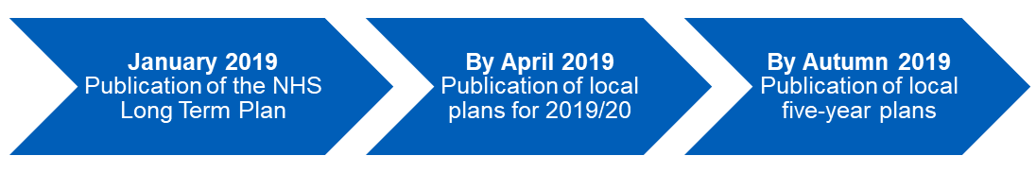

This means that over the next few months, staff, patients and the public will have the opportunity to help shape what the NHS Long Term Plan means for our area, and how the services they use or work in need to change and improve over the next few years.

The four local Healthwatch organisations (Blackburn with Darwen, Blackpool, Lancashire and Cumbria) will receive national funding to support Healthier Lancashire and South Cumbria in ensuring that the views of patients and the public are heard, and Age UK will be leading work across a range of other charities to provide specific opportunities to hear from people with specific health needs.

We intend to involve local people, our staff and the voluntary, community and faith sector in the development of this strategy over the coming weeks and months. More detail for this is included later in this report.

4. Focus on prevention and population health management
In January 2019, Healthier Lancashire and South Cumbria confirmed that nearly half a million pounds is going to be spent in local communities across Lancashire and South Cumbria, tackling the factors which have the greatest impact on people’s health. The ICS is one of four national exemplar areas testing the use of data and intelligence to support improvements in the health of local areas.

The £471,000 investment from NHS England will be used to design better care around our communities’ needs, a priority described in the NHS Long Term Plan. This will see work in areas including Barrow, Blackpool, Burnley, Chorley and Skelmersdale to look at how data and intelligence can be better used by GPs and community services to help people live longer, healthier lives.

One example is using data to identify people who have multiple long term conditions and understanding the ways in which they can be supported to prevent complications and live independently. This approach will be developed across Lancashire and South Cumbria to make a real difference to people’s lives.

The project is led by Dr Sakthi Karunanithi, Director for Public Health and Wellbeing for Lancashire County Council and Senior Responsible Officer for Prevention and Population Health for Lancashire and South Cumbria. Lancashire and South Cumbria is one of four areas in the country to be recognised as leading the way in starting to improve outcomes, reduce inequalities and address the broad range of individual, social and economic factors affecting the health of local people.

Taking a whole population approach means working collaboratively beyond the boundaries of health and care services to support people to stay healthy and avoid complications from existing illnesses. It will enable care to be delivered in the right place and at the right time for local people and their families.

5. Commissioning Development
A Commissioning Development Framework for Lancashire and South Cumbria acknowledges that the Five Year Forward View has led to changes in the roles and functions of commissioners with a greater focus on collaboration rather than competition between NHS organisations. Our desire across Lancashire and South Cumbria is to focus on collective efforts to improve the health and wellbeing of the whole population, improve outcomes and quality of services and work towards the financial sustainability of local services. Increasingly this is blurring the boundaries between commissioners and providers.

Consequently, our work on commissioning development is running in parallel with provider development, focussed on the forging alliances of providers within our Integrated Care Partnerships, with the capacity and capability to take on roles that we currently call commissioning. For example, needs assessment, service planning, service redesign, quality improvement.

The Framework recommends that we adopt a “place-based approach” to the evolution of commissioning in Lancashire and South Cumbria, identifying the services that should be commissioned once across L&SC; within each ICP to the same standards and outcomes; and within each of our developing neighbourhoods. Place based commissioning means:

- Commissioning organisations (health and local government) should work together to govern the common resources available for improving health and care in their area
- The approach taken to developing local systems of care should be determined using a common set of design and operating principles
- Changes to the roles of commissioners are needed to support the development of systems of care across the ICS and in local Integrated Care Partnerships (ICPs)

The development of our approach to the ICS, ICPs and neighbourhoods reflects a really positive change in the way NHS, Local Authorities and partners work together.

We have therefore been delighted that a range of commissioning colleagues from across the system have been working together in recent months to think about our future commissioning arrangements for the following workstreams:
- Adult Mental Health
- Out of Hospital Care
- Children and Young People’s Emotional Wellbeing and Mental Health
- Children, Young People and Maternity services
- Services for people with Learning Disability and Autism
- Services for People with Cancer
- Individual Patient Activity
- Urgent and Emergency care
- Planned Care

Decisions regarding Commissioning Development work continue to be taken at the Joint Committee of Clinical Commissioning Groups. The Joint Committee of Clinical Commissioning Groups has been established since January 2017 and consists of GPs and lay members from each of the Clinical Commissioning Groups in Lancashire and South Cumbria. Chief Executives from Lancashire County Council, Blackburn with Darwen Council, Blackpool Council, representatives from district Councils and local Healthwatch attend the meetings.

6. Finance
A national five year funding settlement for the NHS was announced in June 2018 which will see increased funding of £20.5 billion per year by the end of 2023/24, or an average of 3.4% real growth per annum.

There will be a significant (disproportionately higher) increase in relative investment in primary and community care of at least £4.5bn nationally compared to now which will see expanded neighbourhood teams working together in a more joined up way - from GPs, pharmacists and district nurses to physiotherapists, social care workers and colleagues in the voluntary sector.

We also applaud the move to strengthen work on preventing ill health and tackling health inequalities in the NHS Long Term Plan. This includes the application of a new funding formula which has emphasised the need to take into account deprivation and as a result there have been higher growth in CCGs with high deprivation, such as Blackpool, as shown in the following table:

Core CCG allocations - £ and % increase

 | Adjusted baseline | Final allocation after place-based pace of change
 | 2018-19 | 2019-20 | Movement | Increase
 | £'000 | £'000 | £'000 | %
NHS Blackburn with Darwen CCG | 228,427 | 241,524 | 13,097 | 5.7%
NHS Blackpool CCG | 264,993 | 295,684 | 30,691 | 11.6%
NHS Chorley and South Ribble CCG | 242,465 | 256,031 | 13,566 | 5.6%
NHS East Lancashire CCG | 551,877 | 579,151 | 27,274 | 4.9%
NHS Fylde and Wyre CCG | 262,418 | 276,848 | 14,430 | 5.5%
NHS Greater Preston CCG | 266,262 | 279,286 | 13,024 | 4.9%
NHS Morecambe Bay CCG | 487,503 | 513,282 | 25,779 | 5.3%
NHS West Lancashire CCG | 152,486 | 160,160 | 7,674 | 5.0%
Healthier Lancashire and South Cumbria | 2,456,431 | 2,601,966 | 145,535 | 5.9%

New commitments for action that the NHS itself will take to improve prevention to complement local government and in which will be supported by targeted funding for health inequalities of more than £1bn by 2023/2024. The priorities for this are initiatives to tackle smoking, high blood pressure, obesity, alcohol and drug use, air pollution and lack of exercise.

Increased investment in primary and community care, which will expand neighbourhood teams to support strong population health management.

Lancashire and South Cumbria will be expected to set out how we will reduce health inequalities as a system as part of the population health management proposals.

7. Involving and co-production with local people and patients
Healthier Lancashire and South Cumbria is committed to ensuring that the process of engagement, communication, involvement and consultation with the public, staff, voluntary and community organisations, councillors and other stakeholders is delivered in line with national best practice.

Good communications, engagement and involvement with stakeholders will mean:
- Better decision making - involving patients and stakeholders in decisions about their own health and care has the potential to boost outcomes, improve patient experience and reduce unnecessary consultations
- Improved ability to deliver difficult change – developing ideas and proposals with patients, the public and community organisations from the outset can increase our ability to manage risk and deliver difficult change successfully
- More effective service delivery - understanding patient experiences can help us to identify areas of waste and inefficiency and how to improve services
- Reduced demand - engaging people can help manage demand for services by improving lifestyle choices, improving self-care and encouraging people to use services appropriately
- More informed public opinion - to help us decide how to make the best use of the money available
- Greater community support - engaging with communities and acknowledging the assets that they possess can help tackle health inequalities, support behaviour change and improve health and wellbeing

In October 2018, an Engagement and Consultation Framework was agreed by the Joint Committee of CCGs which sets out the principles of involvement, engagement and consultation that partners will work to in Lancashire and South Cumbria for substantial changes to services.

The purpose of this document is to set out:

- The proposed governance process for the coordination of, and support for, engagement and consultation concerning substantial change to services across Lancashire and South Cumbria.
- The proposed principles and framework the Joint Committee of the Clinical Commissioning Groups (JCCCGs) should adopt on behalf of itself and to guide other partners, including the Healthier Lancashire and South Cumbria as the integrated care system

Together the principles and framework are designed to ensure modern, inclusive and meaningful involvement, engagement and consultation with patients, public, staff and stakeholders.

In developing and setting a five year strategy for Lancashire and South Cumbria we believe it needs to be built upon high levels of engagement and involvement at the earliest possible stage with a range of stakeholders and will be influenced by the engagement which takes place throughout its development.

A considerable amount of engagement work has taken place over the past two years on a local level which the strategy will be built upon. We want to make sure people have the opportunity to shape the plans at every stage over the coming weeks and months to make sure we have a strategy for Lancashire and South Cumbria which is fit for purpose.

The development of the strategy involves collaborative working with our five Integrated Care Partnerships. This will build upon existing engagement and communication structures which are in place within the ICPs and ownership needs to be demonstrated at the most local level of place.

Glossary of Terms
There can be lots of confusion created when people use the same terms to mean different things. There is not yet a clear and nationally shared approach to defining the new system.

For the purposes of ensuring that our framework is understood locally, the following terms are used throughout and their meaning defined simply, as follows:
- Integrated care system (ICS) previously known nationally as STP - the whole system that we are seeking to create across Lancashire and South Cumbria (involving commissioners, providers and regulators) called Healthier Lancashire and South Cumbria. This is the partnership of NHS, Local Authority, Public Sector and other organisations working to deliver our five year Sustainability and Transformation Plan that describes how we will improve quality, develop new models of care; improve health and wellbeing; and improve efficiency of services
- Integrated Care Partnerships (ICPs) previously known Local Delivery Partnerships - sub Lancashire and South Cumbria level partnerships i.e. Pennine, Fylde Coast, West Lancashire, Morecambe Bay, Central Lancashire. The definition in Lancashire and South Cumbria differs from the NHS Long Term Plan. Our use of the term refers to the partnership definition as this has already been established in Lancashire and South Cumbria.
- Neighbourhood - sub ICP area level systems e.g. Fleetwood, Millom etc., (which may or may not align to local authority districts, depending on local arrangements)
- Place based commissioning - commissioners organising themselves so that they collaborate together to address the challenges and improve the health of any defined population

A more detailed glossary of terms is available here: www.healthierlsc.co.uk/about/glossary

